**CHAPTER 6-SYSTEM DESIGN/ARCHITECTURE**

* 1. **) BLOCK DIAGRAM**

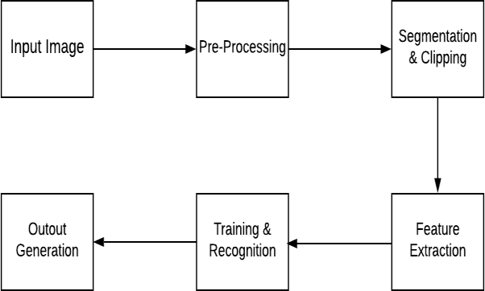

The above diagram depicts the architecture of our proposed system. The first step involves providing an image of a handwritten digit to the proposed system as the input. Various processes are carried out on the input image. The image is upgraded and is made suitable for segmentation. Processes like smoothing and standardization of the images are carried out in this stage. Binarization converts a gray-scale image to a binary image. Next, sub-images are formed of the images taken as input. A number is assigned to each digit. Each digit is reconverted into pixels. Edge detection technique is used for the process of segmentation. Next, the images are depicted in the form of a matrix which consists of pixels of images that are very large. This process is popularly known as feature extraction. Repetition of data is removed in this stage. Finally, the feature vectors are given as input to various classifiers such as K-Nearest Neighbor, Support Vector Machine etc. Finally, the output is generated in the last stage.

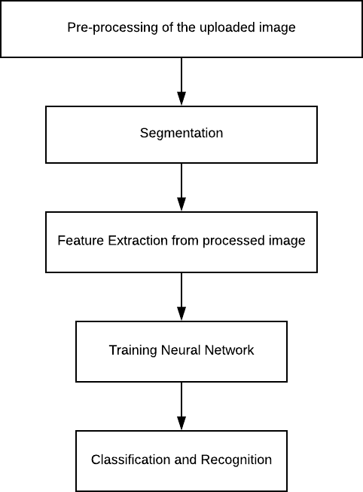

9

**6.2) SEQUENCE DIAGRAM**

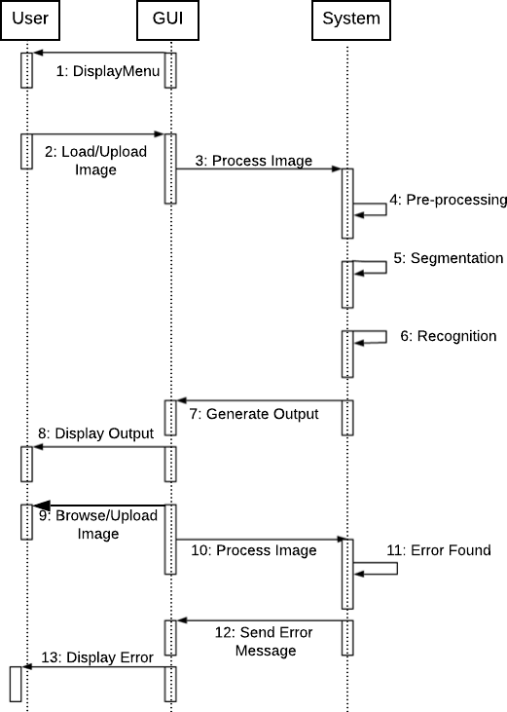

First of all, the GUI displays a menu to the user. The user loads or uploads an image into the GUI. The GUI processes the image and sends it to the system. The system pre-processes the image and carries out segmentation and recognition of the various image. The system then generates the output and passes it to the GUI. The GUI displays the output for the viewer to see. The user can browse and upload an image. The GUI sends the image for processing it. If an error is found, an error image is sent to the GUI which further displays the error and its details at the user’s end. This is the sequence of steps to carry out recognition of images of handwritten digits.

10

**6.3) DATA FLOW DIAGRAM**

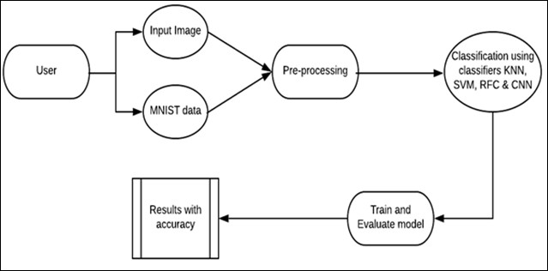

The above diagram shows the flow of data in Handwritten Digit Recognition system. The user can provide input image in two ways- either he can upload the image of the digit to be recognized or the digit image can be taken from the MNIST dataset. The input image provided by the user is pre-processed. The processed images are then classified using various classifiers such as Support Vector Machine, Convolution Neural Network, Artificial Neural Network etc. The classified images are then trained and evaluated in the next stage. The results are then shown with accuracy to the user.